JENKINS Tool Overview

Table of Contents

1. Exercise 2.1: Install Jenkins and Access the Dashboard 3
2. Exercise 2.2: Configure Jenkins 8
3. Exercise 2.3: Install Plugins 11
4. Exercise 3.1: Build Job 14
5. Exercise 4.1: Create a Job and Analyze Code in Jenkins 22
6. Exercise 5.1: Create a Job to Deploy WAR File in Jenkins 31
7. Exercise 6.1: Test application with Selenium 36
8. Exercise 7.1: Create Job Pipeline 40

Module 2

# Exercise 2.1: Install Jenkins and Access the Dashboard

## Scenario

|  |
| --- |
| Perform activities to install Jenkins and to get started with tasks |

## Prerequisite: Java 8( jdk1.8 ), 512 MB RAM

## Walkthrough

1. Download and install the war file
2. Set the initial admin password
3. Install suggested plugins
4. Create first admin user and start accessing the Jenkins dashboard

## Steps

1. Download and install the war file

|  |  |
| --- | --- |
| 1 | 1. Navigate to <https://jenkins.io/download/> 2. Download **Generic Java package (.war)** and save it into your local disk. Example: **C:\Softwares** |
| 2 | Open Command prompt and set the JENKINS_HOME directory by executing the below command:  **C:\Softwares>set JENKINS_HOME=C:\Jenkins** |
| 3 | Install Jenkins in the port 8082 by executing the command as highlighted in the below screen  **java -jar jenkins.war --httpPort=8082**  Note: By default, Jenkins get started in the port number 8080.  The command prompt displays the following message, when Jenkins starts running successfully |

1. Set the initial admin password

|  |  |
| --- | --- |
| 1 | You can access Jenkins in the path: [http://localhost:808](http://localhost:8084)2  To start working with Jenkins dashboard, first set the administrator password as provided in the location: **C:/Jenkins\Secrets\initialAdminPassword** |
| 2 | Copy the admin password provided in the location and paste it as shown below and click **Continue**    The Jenkins displays the following screen to install plugins before you start accessing the dashboard |

1. Install suggested plugins

|  |  |
| --- | --- |
| 1 | Click **Install suggested plugins**    The following screen appears to indicate the default plugins that are installed successfully: |

1. Create first admin user and start accessing the Jenkins dashboard

|  |  |
| --- | --- |
| 1 | Enter the respective details for the fields, and click **Save and Finish** to complete Jenkins setup |
| 2 | Click **Start Using Jenkins**, when the setup is complete    You can now start using the Jenkins dashboard |

# Exercise 2.2: Configure Jenkins

## Scenario

|  |
| --- |
| Perform activities to configure Jenkins with JDK, Git, Maven and Ant |

## Prerequisite: Working knowledge of JDK, GIT, Maven and Ant

**Note:**

1. The Software’s will be shared by faculty.(Git,Maven,Ant,JDK).
2. The JDK, Git, Maven and Ant to be stored in the C:\Softwares of the local system.

## Walkthrough

1. Access Global Tool Configuration section
2. Configure Jenkins with JDK
3. Configure Jenkins with Git
4. Configure Jenkins with Maven
5. Configure Jenkins with Ant and save all the configurations

## Steps

1. Access Global Tool Configuration section

|  |  |
| --- | --- |
| 1 | Open the Jenkins dashboard in the URL [http://localhost:808](http://localhost:8084)2 |
| 2 | Navigate to **Manage** **Jenkins 🡪 Global Tool Configuration** option    This results in the **Global Tool Configuration** page, where you can choose the components to configure Jenkins with. |

1. Configure Jenkins with JDK

|  |  |
| --- | --- |
| 1 | 1. In the Global Tool Configuration page, navigate to the **JDK** section 2. Click **Add JDK** |
| 2 | 1. Uncheck the **Install automatically** checkbox 2. Specify the name and path of the JDK installed in the system in the JAVA_HOME field as shown below   C:\Users\vishnu.k.kallimakula\AppData\Local\Microsoft\Windows\INetCache\Content.Word\JDK1.8.png |

1. Configure Jenkins with Git

|  |  |
| --- | --- |
| 1 | 1. Navigate to the **Git** section 2. Click **Add Git** |
| 2 | 1. Uncheck the **Install automatically** checkbox 2. Specify the name and path of the Git installed in the **Path to Git executable** field as shown below |

1. Configure Jenkins with Maven

|  |  |
| --- | --- |
| 1 | 1. Navigate to the **Maven** section 2. Click **Add Maven** |
| 2 | 1. Uncheck the **Install automatically** checkbox 2. Specify the name and path of the Maven stored in your local system in the **M2_HOME** field as shown below   C:\Users\vishnu.k.kallimakula\AppData\Local\Microsoft\Windows\INetCache\Content.Word\Maven.png |

1. Configure Jenkins with Ant and save all the configurations

|  |  |
| --- | --- |
| 1 | 1. Navigate to the **Ant** section 2. Click **Add Ant** |
| 2 | 1. Uncheck the **Install automatically** checkbox 2. Specify the name and path of the Ant installed in the **ANT_HOME** field as shown below   C:\Users\vishnu.k.kallimakula\AppData\Local\Microsoft\Windows\INetCache\Content.Word\Ant.png |
| 3 | Click the **Save** button to save the JDK, Git, Maven and Ant configurations |

# Exercise 2.3: Install Plugins

## Scenario

|  |
| --- |
| Perform activities to install plugins that facilitates to perform tasks in Jenkins. |

## 

## Walkthrough

1. Search and install the required plugins

## Steps:

|  |  |
| --- | --- |
| 1 | In Jenkins dashboard, navigate to **Manage Jenkins 🡪 Manage Plugins** option.    You will see the **Plugin Manager** page |
| 2 | 1. In the Plugin Manager page, click the **Available** tab 2. Search for the required plugins 3. Check the box for the required plugins 4. Click the **Install without restart** tab     Note: Select the plugins shown below to install: |
|  | All the selected plugins will be installed and ready to use in Jenkins  **Note: We can install all plugins which are required for a project by following the above procedure.** |

End of Module 2

Module 3

# Exercise 3.1: Build Job

## Scenario

|  |
| --- |
| Perform activities to build job in Jenkins. |

## Prerequisite:

1. Working knowledge of GIT and Maven
2. The project to build should be created in GitHub server (The steps are included below)
3. JDK, Git, Maven and Ant should be stored in the C:\Softwares of the local system to perform this exercise.

Note:

1. This exercise uses GitHub server to store source code and Maven to build project
2. The source code will be shared by faculty
3. The ProjectSourceCode should be stored in C:\Softwares of the local system.

## Walkthrough

1. Install Git
2. Create project in GitHub server
3. Create job in Jenkins and configure it with the GitHub project
4. Configure Source Code Management with Git
5. Configure build job using Maven
6. Execute build
7. View build results

## Steps

1. Install Git

|  |  |
| --- | --- |
| 1 | Following are the steps to install Git:   1. Click on Git Download Git from the below URL 2. <https://git-for-windows.github.io/> 3. Start installation 4. Select “Git bash” and “Git GUI” 5. Select “Use Git from windows command prompt” 6. Keep remaining options as default and click Install button. 7. If Git installation is completed successfully, then follow these steps. 8. Navigate and select Git Bash |

1. Create project in GitHub server

|  |  |
| --- | --- |
| 1 | Sign in to the GitHub server   1. You are required to sign up to GitHub at **https://github.com/** 2. While signup, please provide your mail id as an email address. 3. (Confirmation link will be sent). 4. Once the account is created, login to the account. |
| 2 | Create repository   1. Click **New repository** from the drop-down list of the GitHub home page      1. Specify the name (example: Project) in the **Repository name** field and click the checkbox next to **Initialize this repository with** **README** option 2. Click the **Create Repository** button to create repository in GitHub server |
| 3 | Clone the repository  Clone the project that you created by using the **git clone** command. The path to the project can be found in GitHub server: The path looks as shown below as per your credentials:  git clone <https://github.com/vishnukiranreddy4/Project.git> |
| 4 | Navigate to Git bash on your workstation and make sure that you have changed the directory to the right directory where you want to clone your project and execute the git clone command( Create a folder JenkinsPractice in C drive)   1. cd /c/JenkinsPractice 2. git clone <https://github.com/vishnukiranreddy4/Project.git> |
| 5 | Change to your Git repository directory:   * cd Project |
| 6 | Copy the project content into the "Project" folder manually from the path **C:\Softwares\ProjectSourceCode\Module3** without using Git command  Note: Copy the code which is present in ProjectSourceCode\Module3 folder(**C:\Softwares\ProjectSourceCode\Module3**) into **Project** folder(Cloned from the GitHub Server). |
| 7 | After copying content, navigate to git bash and execute the below commands   * git add . * git status * git config --global user.email <gitloginemail>   For Ex: git config --global user.email “vishnureddy224@gmail.com”   * git commit -m "Adding project content" * git push origin master   Now, the project is pushed to GitHub server  Note: Enter password which you have given while creating the account in GitHub. |
|  |  |

1. Create job in Jenkins and configure it with the GitHub project

|  |  |
| --- | --- |
| 1 | Access Jenkins Dashboard using the URL [**http://localhost:8082**](http://localhost:8082) |
| 2 | Select **New Item** from the menu as highlighted in the below image. |
| 3 | 1. Type the job name as ‘CompileandPackage’ in the **Enter an item name** field and select **Freestyle Project** as the project type as shown below: 2. Click **OK** to create job   C:\Users\vishnu.k.kallimakula\AppData\Local\Microsoft\Windows\INetCache\Content.Word\Compile.png  This action leads to the **Project Configuration** page, where you can configure settings for build activity |
| 4 | To configure job with GitHub project, perform the following tasks:   1. In the **Project Configuration page**, under the **General** tab, type the details in the **Description** field   C:\Users\vishnu.k.kallimakula\AppData\Local\Microsoft\Windows\INetCache\Content.Word\Git.png |

1. Configure Source Code Management (SCM) with Git

|  |  |
| --- | --- |
| 1 | 1. In the Project Configuration page, navigate to the **Source Code Management** section 2. Select **Git** 3. Specify the path in **Repository URL(**Copy your Repository URL from GitHub Server and specify here**)** |
| 2 | Add credentials:   1. Click **Add** button to add username and password of GitHub account 2. Click **Jenkins**     This leads to the **Jenkins Credentials Provider** page.   1. Provide username and password of the GitHub server 2. Click **Add**      1. Select the **credentials** from the drop-down list |

1. Configure build job using Maven

|  |  |
| --- | --- |
| 1 | Now, build job by using the Maven commands as follows:   1. Navigate to the **Build** section 2. Choose **Invoke top level Maven targets** from the **Add build step** drop-down menu 3. Specify the Maven version as shown in the screen capture below 4. Type the target name as **compile package** against the **Goals** field     Now, the configuration set up is complete to perform build activity |

1. Execute build

|  |  |
| --- | --- |
| 1 | After the configurations are complete, execute build job manually as follows:   1. Click the **Save** button in the Project Configuration page 2. Navigate to the Jenkins dashboard and select **CompileandPackage** project 3. Click **Build Now** to schedule the build to execute immediately   C:\Users\vishnu.k.kallimakula\AppData\Local\Microsoft\Windows\INetCache\Content.Word\Build.png  The artifacts (jar/war/ear files) are created on successful build of the project |

1. View build results

|  |  |
| --- | --- |
| 1 | To view build results, click **#1**, the build number under **Build History** of the job in the Jenkins dashboard |
| 2 | Click **Console Output**  C:\Users\vishnu.k.kallimakula\AppData\Local\Microsoft\Windows\INetCache\Content.Word\Console.png  This action will retrieve build results and display them in the console:  C:\Users\vishnu.k.kallimakula\AppData\Local\Microsoft\Windows\INetCache\Content.Word\CO-Build.png |

End of Module 3

Module 4

# Exercise 4.1: Create a Job and Analyze Code in Jenkins

|  |
| --- |
| Perform activities to analyze code using SonarQube Scanner in Jenkins |

## Prerequisite:

1. Java8(jdk1.8) should be installed in the system.
2. SonarQube and Sonar Scanner to be stored in the C:\Softwares of the local system
3. The project in GitHub server used in Exercise 3.1 is considered in this exercise to perform code analysis

Note:

1. SonarQube and SonarQube Scanner will be provided by faculty during session
2. The SonarQube 6.5 version is used in this exercise

## Walkthrough

1. Install SonarQube
2. Install SonarQube Scanner plugin
3. Configure Jenkins with SonarQube
4. Configure Jenkins with SonarQube Scanner
5. Create job in Jenkins and configure it with the GitHub project
6. Configure SCM with Git
7. Configure job using Maven.
8. Perform code analysis using SonarQube Scanner
9. View analysis results

## Steps

1. Install SonarQube

|  |  |
| --- | --- |
| 1 | Navigate to **C:\Softwares\sonarqube-6.5\bin\windows-x86-64** folder |
| 2 | 1. Click on **StartSonar** to start the SonarQube server. 2. Once we click on StartSonar, SonarQube server will be up and running.      1. You can access SonarQube in the path: <http://localhost:9000>   Note: By default Sonarqube starts with port number is 9000.     1. **Log in** to the SonarQube server with the following credentials:   Username: admin  Password: admin |

1. Install SonarQube Scanner plugin

|  |  |
| --- | --- |
| 1 | In Jenkins dashboard, navigate to **Manage Jenkins 🡪 Manage Plugins** option. |
| 2 | 1. Click the **Available** tab under Plugin Manager page and then search and select **SonarQube Scanner for Jenkins** plugin      1. Click **Install without restart** to install the plugin |

1. Configure Jenkins with SonarQube

|  |  |
| --- | --- |
| 1 | Open the Jenkins dashboard in the URL [http://localhost:808](http://localhost:8084)2 |
| 2 | Navigate to **Manage** **Jenkins 🡪 Configure System**    This results in the **Configuration** page, where you can choose the components to configure Jenkins with. |
| 3 | 1. In the Configuration page, navigate to the **SonarQube Servers** section 2. Click the boxnext **to Enable injection of SonarQube server configuration as build environment variables** 3. Click **Add** **SonarQube** and provide required details as shown below**:**     Note: **Server authentication token** is generated in SonarQube server. To generate token, perform the following steps:   1. Access SonarQube server by using the link <http://localhost:9000> 2. **Log in** to the SonarQube server with the following credentials: username: admin, password: admin 3. Click **A** at the top right-handcorner 4. Navigate to **My Account**🡪**Security** 5. Specify thetoken nameand then click the **Generate** button to generate the token     Copy the token and use it while configuring SonarQube server in Jenkins |
| 5 | Click the **Save** button to save the SonarQube server configuration |

1. Configure Jenkins with SonarQube Scanner

|  |  |
| --- | --- |
| 1 | Open the Jenkins dashboard in the URL [http://localhost:808](http://localhost:8084)2 |
| 2 | Navigate to **Manage** **Jenkins 🡪 Global Tool Configuration** option    This results in the **Global Tool Configuration** page, where you can choose the components to configure Jenkins with. |
| 3 | In the Global Tool Configuration page, navigate to the **SonarQube Scanner** section and Click **SonarQube Scanner Installations** |
| 4 | 1. Uncheck the box next to **Install automatically** 2. Specify the name and path of the SonarQube Scanner in the **SONAR_RUNNER_HOME** field. The example is shown in the following capture: |
| 5 | Click the **Save** button to save the SonarQube Scanner configuration |

1. Create job in Jenkins and configure it with the GitHub project

|  |  |
| --- | --- |
| 1 | Access Jenkins Dashboard using the URL **http://localhost:8082** |
| 2 | Select **New Item** from the menu as highlighted in the below image. |
| 3 | 1. Type the job name as ‘CodeAnalysisonSonar’ in the **Enter an item name** field and select **Freestyle Project** as the project type as shown below: 2. Click **OK** to create job   C:\Users\vishnu.k.kallimakula\AppData\Local\Microsoft\Windows\INetCache\Content.Word\Code.png  This action leads to the Project Configuration page, where you can configure settings for build activity |
| 4 | To configure job with GitHub project, perform the following tasks:   1. In the **Project Configuration page**, under the **General** tab, type the details in the **Description** field   C:\Users\vishnu.k.kallimakula\AppData\Local\Microsoft\Windows\INetCache\Content.Word\Codeanalysis.png |

1. Configure SCM with Git

|  |  |
| --- | --- |
| 1 | 1. In the Project Configuration page, navigate to the **Source Code Management** section 2. Select **Git** |
| 2 | 1. Specify the path in **Repository URL** 2. To add credentials, click **Add** button to add username and password of GitHub account 3. Select the credentials from the drop-down list |

1. Configure job using Maven

|  |  |
| --- | --- |
| 1 | Configure the job by using the Maven commands as follows:   1. Navigate to the **Build** section 2. Choose **Invoke top level Maven targets** from the **Add build step** drop-down menu 3. Specify the Maven version as shown in the screen capture below 4. Type the target name as **compile package** against the **Goals** field |

1. Perform code analysis

|  |  |
| --- | --- |
| 1 | To perform code analysis by using SonarQube Scanner, follow the steps below:   1. Navigate to the **Build** section 2. Choose **Execute SonarQube Scanner** from the **Add build step** drop-down menu 3. Provide the details for **Analysis Properties** as shown below   **Note:** Copy the properties from the **sonar-project** file present in the **ProjectSourceCode\Module3.**  C:\Users\vishnu.k.kallimakula\AppData\Local\Microsoft\Windows\INetCache\Content.Word\SOnar.png  Now, the configuration set up is complete to perform code analysis.   1. Click the **Save** button in the Project Configuration page |
| 2 | After the configurations are complete, execute analysis manually as follows:   * 1. Navigate to the Jenkins dashboard and select **CodeAnalysisonSonar** project   2. Click **Build Now** to execute code analysis   C:\Users\vishnu.k.kallimakula\AppData\Local\Microsoft\Windows\INetCache\Content.Word\test.png |

1. View analysis results

|  |  |
| --- | --- |
| 1 | To view build results, click **#1**, the build number under **Build History** in the Jenkins dashboard for the project, Code Analysis on Sonar |
| 2 | Click **Console Output**  C:\Users\vishnu.k.kallimakula\AppData\Local\Microsoft\Windows\INetCache\Content.Word\test1.png  This action will retrieve results in console.  C:\Users\vishnu.k.kallimakula\AppData\Local\Microsoft\Windows\INetCache\Content.Word\CO-CA.PNG   * Access the above link in the console output to see the analysis results   C:\Users\vishnu.k.kallimakula\AppData\Local\Microsoft\Windows\INetCache\Content.Word\Sonarqube.png |

End of Module 4

Module 5

# Exercise 5.1: Create a Job to Deploy WAR File in Jenkins

|  |
| --- |
| Perform activities to create a project and deploy it in Tomcat server |

## Prerequisite:

1. Add the **Deploy to Container Plugin** and **Copy Artifacts Plugin** to Jenkinsto perform deployment (Install the plugin as mentioned in the steps in the exercise 2.3)
2. Tomcat should be installed in your local system
3. The artifact created in Exercise 3.1 is considered in this exercise for deployment in Tomcat
4. A ‘Free Style Project’ named **DeploytoTomcat** should be created in Jenkins for deployment (Please follow the steps in exercise 3.1 to create the job)

Note:

1. Tomcat will be shared by the faculty during the session.

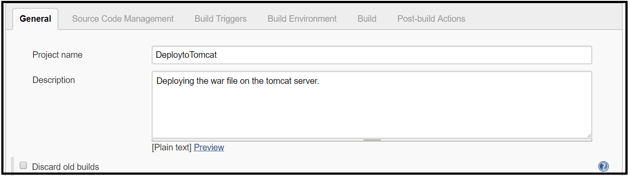

## Walkthrough

1. Perform build activities to deploy the project
2. Perform post build tasks to deploy the project
3. Execute project deployment
4. View results

## Steps

1. Perform build activities to deploy the project

|  |  |
| --- | --- |
| 1 | In the Project Configuration page, navigate to the **Build** section |
| 2 | Choose **Copy artifacts from another project** from the **Add build step** drop-down list |
| 3 | 1. Specify **CompileandPackage** as **Project Name** (i.e., Project from which we should copy the artifacts) 2. Select **Copy from WORKSPACE of the latest completed build** from the drop-down list   C:\Users\vishnu.k.kallimakula\AppData\Local\Microsoft\Windows\INetCache\Content.Word\Artifact.png |

1. Perform post build tasks to deploy the project

|  |  |
| --- | --- |
| 1 | In the Project Configuration page, navigate to the **Post-build Actions** section |
| 2 | Configure Tomcat to deploy project   1. From the **Add Post-build action** drop-down list, choose **Deploy war/ear to a container** 2. Specify **WAR/EAR files** as **\*\*/*.war** 3. Specify **Context Path** as petclinic.war 4. Click **Add Container** drop-down menu and choose **Tomcat 7.x** and provide the details as shown below 5. Click **Add** to add credentials of Tomcat and select it from the drop-down list   C:\Users\vishnu.k.kallimakula\AppData\Local\Microsoft\Windows\INetCache\Content.Word\Deploy-pA.PNG   1. Click **Save** to save the configurations |

1. Execute project deployment

|  |  |
| --- | --- |
| 1 | Now that the deployment configurations are complete, execute deployment job manually by following the below steps:   1. In the Jenkins dashboard, navigate to the **DeploytoTomcat** project 2. Schedule the deployment to be executed immediately by clicking **Build Now**   C:\Users\vishnu.k.kallimakula\AppData\Local\Microsoft\Windows\INetCache\Content.Word\Deploy1.png |

1. View results

|  |  |
| --- | --- |
| 1 | To view build results, click **#1**, the build number under **Build History** in the Jenkins dashboard for the project, Deploy to Tomcat |
| 2 | Click **Console Output**  C:\Users\vishnu.k.kallimakula\AppData\Local\Microsoft\Windows\INetCache\Content.Word\Deploy2.png  This action will retrieve results in console. |
| 3 | To verify deployment, perform the following tasks:   1. Go to browser and access the link <http://localhost:8080> to see the Tomcat home page 2. Click the **Manager App** icon to see the deployed war file (i.e., petclinic.war)      1. Click the **petclinic.war** file to check the output   C:\Users\vishnu.k.kallimakula\AppData\Local\Microsoft\Windows\INetCache\Content.Word\OP.PNG  You can see that the deployed application is up and running  C:\Users\vishnu.k.kallimakula\AppData\Local\Microsoft\Windows\INetCache\Content.Word\Pet.png |

End of Module 5

Module 6

# Exercise 6.1: Test application with Selenium

## Scenario

|  |
| --- |
| Perform activities to test with Selenium and view test results using TestNG in Jenkins |

## Prerequisite:

* The project will be provided by the faculty to test the application with selenium.
* Include the plugin, TestNG Results Plugin to view TestNG results
* Add **Selenium Plugin** to test the application with Selenium
* **Mozilla Firefox** and **Google Chrome** should be installed for testing

Note:

1. The source code will be shared by faculty
2. The ProjectSourceCode should be stored in C:\Softwares of the local system.

## Walkthrough

1. Create project in GitHub server.
2. Create job in Jenkins and configure it with the GitHub project
3. Configure Source Code Management with Git
4. Configure build with Maven and test results with TestNG
5. View results using TestNG

## Steps

1. Create project in GitHub server.

|  |  |
| --- | --- |
| 1 | Sign in to the GitHub server |
| 2 | Create repository   1. Click **New repository** from the drop-down list of the GitHub home page      1. Specify the name (example: Project-Testing) in the **Repository name** field and click the checkbox next to **Initialize this repository with** **README** option 2. Click the **Create Repository** button to create repository in GitHub server   C:\Users\vishnu.k.kallimakula\AppData\Local\Microsoft\Windows\INetCache\Content.Word\Git23.png |
| 3 | Clone the repository  Clone the project that you created by using the **git clone** command. The path to the project can be found in GitHub server: The path looks as shown below as per your credentials:  git clone https://github.com/vishnukiranreddy4/Project-Testing.git |
| 4 | Navigate to Git bash on your workstation and make sure that you have changed the directory to the right directory where you want to clone your project and execute the git clone command( Create a folder JenkinsPractice in C drive)   1. cd /c/JenkinsPractice 2. git clone https://github.com/vishnukiranreddy4/Project-Testing.git |
| 5 | Change to your Git repository directory:   * cd Project-Testing |
| 6 | Copy the project content into the "Project-Testing" folder manually from the path **C:\Softwares\ProjectSourceCode\Module6** without using Git command.  Note: Copy the code which is present in ProjectSourceCode\Module6 folder(**C:\Softwares\ProjectSourceCode\Module6**) into **Project-Testing** folder(Cloned from the GitHub Server). |
| 7 | After copying content, navigate to git bash and execute the below commands   * git add . * git status * git commit -m "Adding project content" * git push origin master   Now, the project is pushed to GitHub server  Note: Enter password which you have given while creating the account in GitHub. |

1. Create job in Jenkins and configure it with the GitHub project

|  |  |
| --- | --- |
| 1 | Select **New Item** in the Jenkins dashboard from the menu as highlighted in the below image. |
| 3 | 1. Type the job name as **Testing the app with Selenium** in the **Enter an item name** field and select **Freestyle Project** as the project type as shown below: 2. Click **OK** to create job     This action leads to the Project Configuration page, where you can configure settings for testing activity |
| 4 | To configure job with GitHub project, perform the following tasks:   1. In the **Project Configuration** page, under the **General** tab, type the details in the **Description** field |

1. Configure Source Code Management with Git

|  |  |
| --- | --- |
| 4 | To configure SCM with GitHub project, perform the following tasks:   1. In the **Project Configuration page**, under the **Source Code Management** section:    1. Select **Git**    2. Specify Repository URL    3. Select the credentials from dropdown    4. Click **Save** to save the configuration   C:\Users\vishnu.k.kallimakula\AppData\Local\Microsoft\Windows\INetCache\Content.Word\Git123.png |

1. Configure build with Maven and test results with TestNG

|  |  |
| --- | --- |
| 1 | To build job using maven commands, do the following steps.   1. Navigate to **Build** section 2. Choose **Invoke top-level Maven targets** from **Add build step** drop-down list. 3. Specify the Maven version and type target name as shown below to execute clean and package goals in Maven |
| 2 | 1. In the Project Configuration page, navigate to the Post-build Actions section 2. From the Add post-build action drop-down items, select Publish TestNG Results 3. Specify the XML report pattern as shown, to save results during build execution |
| 3 | Once configurations are completed, execute build job manually by following the below steps:   1. Click **Save** 2. Schedule the build to be executed immediately by clicking the **Build Now** menu item |

1. View results using TestNG

|  |  |
| --- | --- |
| 1 | View the generated test results by following the below steps:   1. Select the execute build number 2. Click **TestNG Results** link     The test TestNG results are as shown below:  C:\Users\vishnu.k.kallimakula\AppData\Local\Microsoft\Windows\INetCache\Content.Word\TEstng.png |

End of Module 6

Module 7

# Exercise 7.1: Create Job Pipeline

## Scenario

|  |
| --- |
| Perform activities to create pipeline and configure jobs to execute in the Pipeline. |

## Prerequisite:

* Include the plugin**, Build Pipeline Plugin** in Jenkins configuration to create and work with Pipeline
* The jobs to include in the Pipeline should be created before creating Pipeline

Note: This exercise considers 3 jobs, CompileandPackage, CodeAnalysisonSonar and DeploytoTomcat to execute in the Pipeline

## Walkthrough

1. Create Pipeline
2. Configure sequence of jobs in Pipeline
3. Execute Pipeline – 1 Touch and 0 Touch deployment

## Steps

* + 1. Create Pipeline

|  |  |
| --- | --- |
| 1 | To create a pipeline, click on the “+” option in the Jenkins dashboard  C:\Users\vishnu.k.kallimakula\AppData\Local\Microsoft\Windows\INetCache\Content.Word\New.png |
|  | 1. To name the Pipeline, provide the details for **View name** as Hello-Pipeline 2. Check the box next to **Build Pipeline View** 3. Click **OK**     This will successfully create a pipeline and Jenkins will display configurations screen immediately |

* + 1. Configure sequence of jobs in Pipeline

|  |  |
| --- | --- |
| 1 | Select the first job to execute in the Pipeline.   1. In this exercise, select **CompileandPackage** for the **Select Initial Job** field to indicate it as the first job to execute in the Pipeline, Hello-Pipeline as shown below: 2. Click **OK**   C:\Users\vishnu.k.kallimakula\AppData\Local\Microsoft\Windows\INetCache\Content.Word\Pipeline.png |
| 2 | After selecting the initial job, you configure the first job   1. Navigate to the Jenkins Dashboard 2. Click the job, **CompileandPackage** . 3. Click **Configure**   C:\Users\vishnu.k.kallimakula\AppData\Local\Microsoft\Windows\INetCache\Content.Word\C&C.PNG |
| 3 | Next, to configure the second job, **CodeAnalysisonSonar** in the Pipeline,   1. Navigate to the **Post-build Actions** section in the Project Configuration page of the Compile and Package job   C:\Users\vishnu.k.kallimakula\AppData\Local\Microsoft\Windows\INetCache\Content.Word\Git.png   1. From the **Add post-build action** dropdown list, choose **Build other projects** 2. Specify the next job which we want to build after the successful execution of first job, Code Analysis on Sonar as shown below 3. Click **Save**   C:\Users\vishnu.k.kallimakula\AppData\Local\Microsoft\Windows\INetCache\Content.Word\Screen1.png   1. Navigate to the Jenkins dashboard and click the job, **CodeAnalysisonSonar**   C:\Users\vishnu.k.kallimakula\AppData\Local\Microsoft\Windows\INetCache\Content.Word\New1.png   1. Click **Configure**   C:\Users\vishnu.k.kallimakula\AppData\Local\Microsoft\Windows\INetCache\Content.Word\Configure.png  This action leads to the Configuration Page of the Code Analysis on Sonar job, from where you can configure the next job in Pipeline   1. Similarly, by following the same steps mentioned above, configure the third job, DeploytoTomcat on the Project Configuration page of the CodeAnalysisonSonar job |

* + 1. Execute Pipeline – 1 Touch and 0 Touch deployment

|  |  |
| --- | --- |
| 1 | After all the jobs are configured, you can execute jobs as per the specified configuration:   1. Navigate to the Jenkins dashboard 2. Click the **Hello-Pipeline** created 3. Click the **Run** icon (This is for **1 touch** deployment)   C:\Users\vishnu.k.kallimakula\AppData\Local\Microsoft\Windows\INetCache\Content.Word\Screen.png   1. Click **Run**     This action triggers jobs to execute in the specified sequential order.  C:\Users\vishnu.k.kallimakula\AppData\Local\Microsoft\Windows\INetCache\Content.Word\Pipe.png |
| 2 | After all the jobs are configured, you can execute jobs as per the specified configuration for **0 touch** deployment.   1. Navigate to Jenkins dashboard -> CompileandPackage -> Configure 2. Go to Build Triggers section 3. Check the check box **Trigger builds remotely** and enter authentication token (any random text for example:ausdj4537)      1. Click the **Save** button to save the configuration. 2. Go to Jenkins dashboard. Click the **Full name** present in the top right corner and click **Configure** 3. Click the **Show API Token** button 4. Copy the **Name** and **API Token** and save in notepad.      1. Go to **Git Bash** and go to project repository  * cd Project * cd .git * cd hooks * vi post-commit   In the vi editor press **p** to paste the below script.  #!/bin/sh  curl --user **<jenkinslogin>:<API Token>** http://localhost:8082/job/**CompileandPackage**/build?token=**ausdj4537**  echo "jenkins from an external script"   1. Type :**wq**  and press enter 2. Go to **Project** folder(Cloned from GitHub Server) do some changes in the **README** file and push your changes to repository by referring the Exercise 3.1 3. Now you observe the pipeline that is triggered automatically   C:\Users\vishnu.k.kallimakula\AppData\Local\Microsoft\Windows\INetCache\Content.Word\Pipe.png |

Appendix:

Steps to set up environment variable(jdk1.8):

1. Open Jenkins dashboard in the URL [http://localhost:808](http://localhost:8084)2
2. Click on **Manage Jenkins 🡪 Configure System**

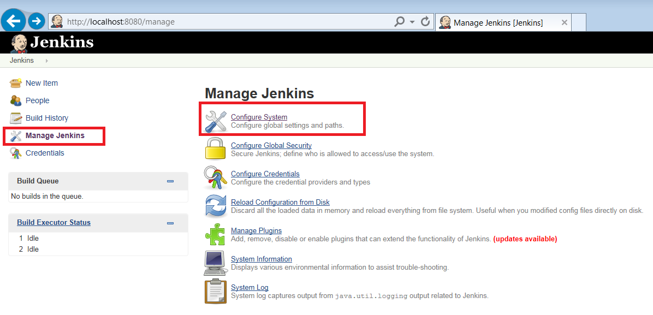

1. Navigate to **Global properties** and check the box next to **Environment variables**.

* Click on Add .
* Specify the name and path of the JDK installed in the system in the JAVA_HOME field as shown below.

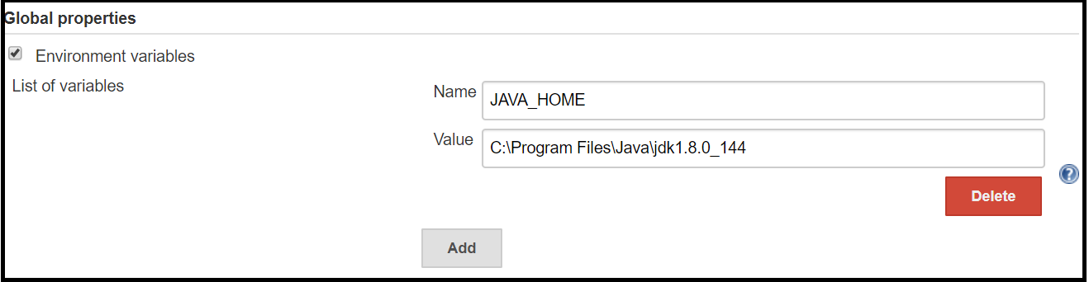

Steps to install Tomcat:

1. Navigate to **C:\Softwares\Apache-Tomcat** folder.
2. Start installation(apache-tomcat-7.0.68).
3. Add the following configurations as shown below:

User Name: admin

Password: admin

Roles: manager-gui,**manager-script**

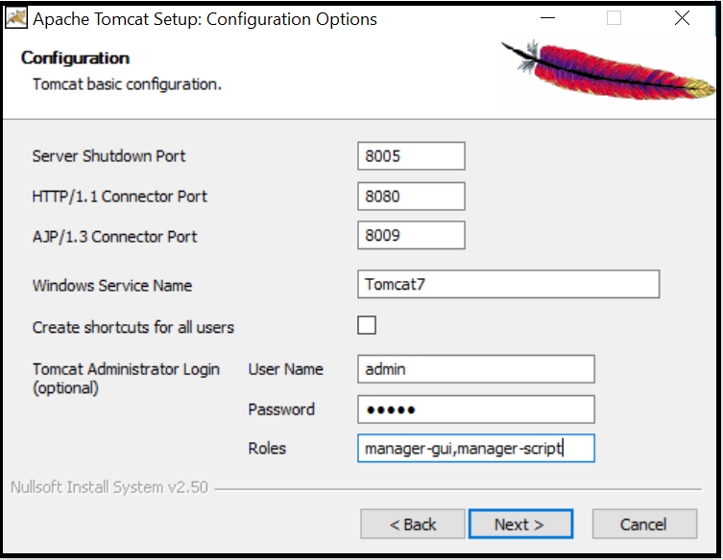

1. Keep remaining options as default and click in Install button.
2. Once the installation is successfully completed, you can access tomcat in the path <http://localhost:8080>

**Note**: By default, Tomcat starts with port number 8080.

End of exercises